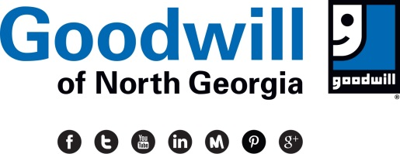

**Skills Training**

**Credentialed training for today’s jobs**

**Information Sessions**

**Athens**: Every **Monday, 10:30am**. 4070 Lexington Road, Athens, GA 30605

(706) 395-1576

**Cartersville**: Every **Tuesday, 10am**.

929 Joe Frank Harris Parkway SE, Cartersville, GA 30120, (770) 276-7036

**Cornelia**: Every **Thursday, 11am**. 308 Habersham Hills Cr, Cornelia, GA 30531

(706) 297-8706

**Decatur**: Every **Thursday, 2pm**. 2201 Lawrenceville Highway, Suite 200, Decatur, GA 30033

(404) 554-9600

**Pleasant Hill**: Every **Tuesday, 11am**. 1502 Pleasant Hill Road, Duluth, GA 30096

(770) 564-2447

**Metropolitan**: Every Thursday, 2pm.

2160 Metropolitan Parkway

Atlanta, GA 30315

, (770) 795-4231

**Oakwood**: **Every Friday, 11am**. 3715 Mundy Mill Road, Oakwood, GA 30566

(770) 538-4209

**Old National: Every Tuesday, 2pm** 6175 Old National Hwy, Suite 120 Atlanta, GA. 30349⏐ 678.554.0412

**South Dekalb**: Every **Wednesday, 2:00pm**.

1295 Columbia Drive, Decatur, GA 30032

(404) 728- 8605

**Smyrna**: Every **Wednesday, 2:00pm**. 3205 South Cobb Drive, Smyrna, GA 30080

(678) 766-8173

**Stockbridge**: Every **Wednesday, 2:00pm**.

3871 Highway 138 SE,

Stockbridge, GA 30281

(678) 514-0670

**Woodstock**: Every **Thursday, 10am**.

9425 Highway 92, Woodstock, GA 30188, (770) 874-0901

* **Contact Center Specialist:** Learn customer service at a professional contact center
* **Forklift Operation:** Learn to operate up to four different types of forklifts
* **Floor Technician Custodian:** Learn all custodial duties including floor maintenance
* **GoodBIZ:** Prepare for self-employment, develop a comprehensive business plan
* **Construction:** Learn general and highway construction skills: CDL-B
* **Supply Chain:** Learn how you can get your CDL-A License, forklift, Quality Control
* **Medical Coding & Billing/Medical Admin Assistant, Phlebotomy**
* **Healthcare Environmental Services**
* **Technology: IT Services & Support**
* **Logistics:** Learn material handling, order processing, shipping, receiving & more
* **Maintenance Technician:** Learn facility maintenance and repair skills
* **Veteran Services:** Opportunities offered to help veterans find and keep a job
* **Welding:** Become an American Welding Society certified welder
* **Youth Employment Services:** Many services are offered to help youth ages 16-24 find and keep a job